**PROGRESS REPORT**

NAME: 1) B.Keerthana Raj

2) G.Alaka Asritha

**Problem statement:**

**TITLE:- SHESAFE**

**(AI-Based SOS Communicator with Speech Stress & Motion Anomaly Detection for women safety)**

**1. Introduction**

The AI-Based SOS Communicator is a system designed to detect stress in human speech and detect motion anomalies to generate automated SOS alerts. The system leverages speech processing, motion analysis, and AI techniques to analyze audio and movement data in real-time, determining distress situations. This project aims to assist in emergency scenarios where users may be unable to manually send alerts.

**2. Objectives**

The primary objectives of the project include:

* **Speech Stress Detection**: Analyze human speech and detect stress levels using deep learning.
* **Motion Anomaly Detection**: Identify sudden falls or unusual movement patterns using smartphone sensor data.
* **Automated SOS Alerts**: Trigger emergency alerts when stress or motion anomalies are detected.
* **Mobile App Implementation**: Develop an Android application to run real-time AI inference and send alerts.

**3. Methodology**

**3.1 Speech Stress Detection Using MFCC & LSTM**

* **Dataset**: The system uses the RAVDESS Emotional Speech Dataset for training.
* **Feature Extraction**:
  + Mel-Frequency Cepstral Coefficients (MFCCs) are extracted to represent speech characteristics.
  + Features are normalized using MinMaxScaler.
* **Model Training**:
  + An LSTM model is trained to classify speech into 8 emotion categories.
  + The model is optimized with dropout layers to prevent overfitting.
* **Deployment**:
  + The trained model is converted into TensorFlow Lite (TFLite) for mobile integration.
  + The model runs on edge devices to detect distress in real-time.

**3.2 Motion Anomaly Detection Using MobiAct Dataset**

* **Dataset**: The MobiAct dataset is used, which includes:
  + Accelerometer, gyroscope, and orientation data.
  + Activities like walking, running, jumping, sitting, standing, and simulated falls.
* **Feature Extraction**:
  + Motion features such as mean, variance, peak values, and FFT (Fast Fourier Transform) are extracted.
  + Data is normalized using MinMaxScaler.
  + A sliding window technique (100 samples per window) is applied for time-series analysis.
* **Model Training**:
  + LSTM Autoencoder:
    - Trained only on normal motion to learn movement patterns.
    - Anomalies are detected based on reconstruction error.
  + One-Class SVM:
    - Learns normal motion patterns and flags abnormal activities as distress.
* **Deployment**:
  + The trained models are converted into TensorFlow Lite (TFLite) for real-time execution on mobile devices.

**3.3 Mobile App Implementation (Android Studio)**

* **Sensor Integration**:
  + The app uses accelerometer and gyroscope to detect abnormal movement patterns.
  + These sensors continuously collect real-time motion data for anomaly detection.
  + Sensor values are stored in a buffer and processed periodically.
* **Machine Learning Integration**:
  + The TensorFlow Lite (TFLite) model (model.tflite) is loaded for real-time inference.
  + Motion data is fed into the model to compute Mean Squared Error (MSE) between observed and predicted values.
  + If MSE exceeds a defined threshold (5E15f), the app detects distress.
* **SOS Alert System**:
  + The app automatically sends an emergency SMS when distress is detected.
  + It uses SmsManager to send alerts to a predefined emergency contact (+919686648278).
  + Users can manually trigger or cancel an SOS alert via the UI.
* **User Interface (UI)**:
  + It displays the current MSE value, a Send SOS button, and a Cancel SOS button.
  + The UI updates dynamically when the system detects distress.
* **Performance Optimization**:
  + Sensor data is processed in fixed intervals (every 100 ms) to avoid unnecessary computations.
  + Multithreading and synchronized memory handling prevent app crashes.
  + Buffer clearing mechanism optimizes memory usage.

**4. Implementation and Testing**

* Speech Model Accuracy:
  + Achieved 85%+ accuracy in distinguishing stressed and non-stressed speech.
* Motion Model Performance:
  + LSTM Autoencoder showed high precision in detecting motion anomalies.
  + One-Class SVM was fine-tuned using hyperparameter optimization.
* Mobile App Testing:
  + Successfully detected distress situations using motion sensors, to send emergency contacts(current progress). but not via Bluetooth (to be implemented).
  + Real-time SOS alerts were triggered when anomalies were detected.
  + The UI provided a seamless experience for sending and canceling alerts.

**5. Challenges Faced**

* Background noise interference in speech recordings affected accuracy.
* Distinguishing between normal and distress movements required feature engineering.
* Real-time processing constraints required optimization for mobile execution.
* False alarms needed reduction by fine-tuning model thresholds.

**6. Future Enhancements**

* **Bluetooth Integration**:
  + Enable SOS alert transmission using Bluetooth connectivity, allowing distress signals to be sent even without cellular network access.

**7. Conclusion**

The AI-Based SOS Communicator is a cutting-edge solution that integrates speech stress detection, motion anomaly detection, and a mobile-based SOS alert system. By leveraging deep learning models, smartphone sensors, and real-time AI inference, this system plays a crucial role in automated distress detection and emergency response. With further enhancements, it will provide a comprehensive safety mechanism for users in distress situations.

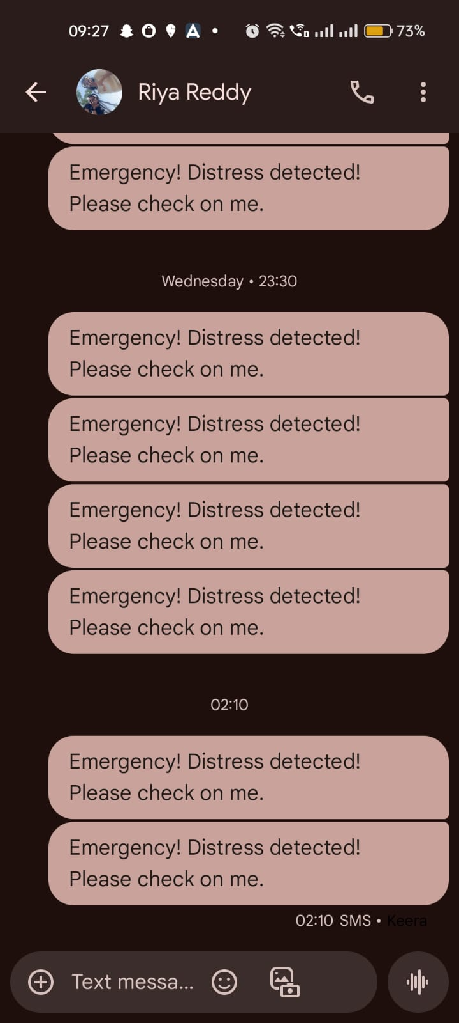**8.Result (Emergency SOS alerts through emergency contacts):**

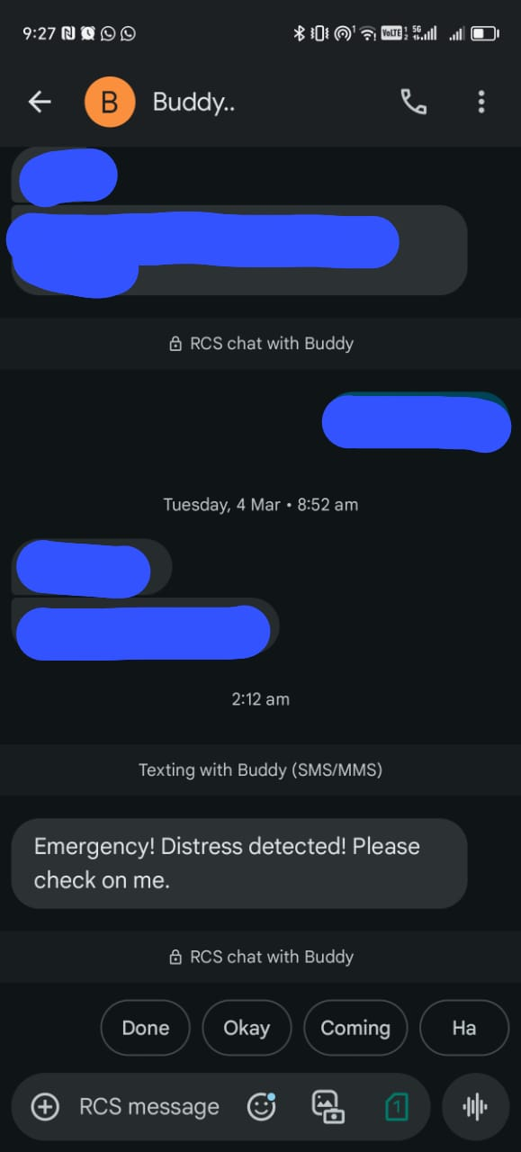

* **Since the Threshold is above the defined limit, the emergency SOS alert has been sent;**



**Mobile Interface (Current progress);**

